JAMESTOWN PARK

Facility Use Guide

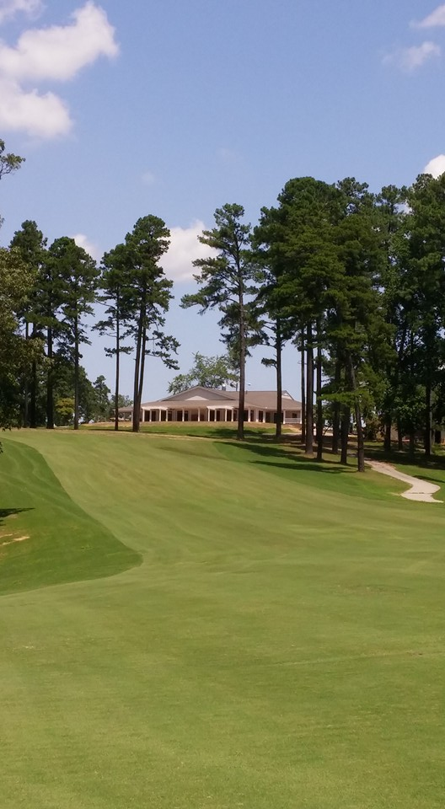

For information or to book an event date

contact Pro Shop at 336-454-4912

Website: http://www.jamestownparkgolf.com/

Thank you for choosing the Jamestown Park Clubhouse for your event. We look forward to working with you in making your event a success. Below is general information about the Clubhouse, which we encourage you to review as soon as possible. Jamestown Park Clubhouse is not available for rent on the evening before Thanksgiving, Thanksgiving Day, Christmas Eve and Christmas. **When you sign the Rental Agreement you will be agreeing that you have read and understand all the information in this Facility Use Guide.** Please contact the Pro Shop staff if you have any questions.

**Rental Agreement, Deposits & Final Payment:** Your reservation will be confirmed when we receive your signed Rental Agreement, Rental Addendum, fees, and deposit. Any additional charges incurred will be deducted from your deposit before the deposit is refunded to you. Make checks payable to “Town of Jamestown”. Anyone leasing the Jamestown Park Clubhouse must be at least **25** years of age. Only the rooms designated in the Agreement are to be used during your event. The person signing the agreement MUST be in attendance throughout the entire function. The person signing this contract is legally responsible for making sure all procedures are followed and it is the responsibility of the signer to ensure that the facility is properly used and cared for. Users are responsible for any and all damages to the facility caused as a result of his/her event and his/her guests. A rental or reservation agreement may NOT be transferred or assigned to any other person or group without approval by the Director of Golf.

**Cost Estimate:** The Rental Addendum is a cost estimate based on the information you gave us at the time of the rental.

**Liability:** You cannot have more people in the room(s) you have rented than our fire capacities allow. Capacity limits are listed below and are subject to change. **When staging tables and chairs for your event, there must be space in front of all entry/exit doors equal to or greater than a six (6) foot radius per the Fire Marshall. There are NO EXCEPTIONS to this rule.** No smoking, vaping, or tobacco products are allowed inside the building. Any damage to the clubhouse caused by you or your guests will be taken out of your Deposit. The Town of Jamestown (dba Jamestown Park) is not responsible for any personal property or equipment brought to or left at the Clubhouse.

The renting individual or group, their guests and invitees, understand and agree that the Town of Jamestown (dba Jamestown Park) will not be responsible for injury to persons using the premises under the terms of the application, nor for damage to or loss of property brought onto the premises, and that the Town of Jamestown (dba Jamestown Park) will be held harmless for any such injury, damage or loss resulting from use of its property, including any court cost and attorney fees.

**Insurance:** All Users shall have either a general liability insurance policy or shall obtain a “Special Event” policy. Said policy must have a certificate of liability insurance naming the Town of Jamestown as an additional insured with at least $1 million of coverage.

The Director of Golf may allow for certain small events with a limited number of people or limited risk without the requirement for an insurance policy. In such cases, a Hold Harmless or Waiver of Liability must be signed releasing the Town of Jamestown and Jamestown Park Golf Course from any and all liability. For certain larger events, the Director of Golf may require more or additional insurance as he or she deems appropriate.

Insurance coverage must coincide with the dates of the User’s contracted event date(s). If the user fails to provide evidence of coverage prior to the event, the Town may cancel the event and user shall forfeit all rights to refunds of any monies paid.

**Catering Services:** Users are welcome to use any caterer on the Jamestown Park Clubhouse list of approved caterers. If you find a caterer you would like to use that is not on the list, we will work to add them provided they meet Jamestown Park Clubhouse requirements. Due to health code restrictions and security requirements, no one may enter the kitchen facilities except the Jamestown Park Clubhouse staff Event Host. If it is agreed the Jamestown Park Clubhouse staff will provide food services, then charges for the same plus applicable taxes and service charges will be included in a Rental Addendum as agreed upon no later than two (2) weeks prior to the event.

**Food Provided by You:** You may bring in your own food or have your guests bring covered dishes. You will need to bring everything related to your food service. Due to health code restrictions and security requirements no one may enter the kitchen facilities except the staff Event Host. **You are responsible for clearing your tables of all trash and placing it in the trashcans we provide**. The Event Host will remove trash bags as necessary and place them in the dumpster. All or a portion of your Deposit will be retained, if necessary, to cover the expense of excessive cleanup or any damages.

**Third-party vendors:** It shall be expressly prohibited to invite any third-party vendor to provide any service without the written permission of the Director of Golf. All third-party vendors shall be subject to the same requirements for insurance as the User.

**Beverage Service:** Due to ABC laws, all alcohol consumed at Jamestown Park Clubhouse must be purchased from and served by the Jamestown Park Clubhouse staff Event Host. Jamestown Park Clubhouse offers a Cash Bar as described in the Fees and Charges Sections.

**Private Businesses:** Private businesses may not rent the facilities for private business endeavors. There is no exception to this requirement.

**Selling Tickets:** The selling of tickets or money exchange is not permitted at the clubhouse, including reselling alcohol from a hosted bar. Businesses selling products and events where the public has been invited and an admission is being charged are expressly prohibited.

**Event Hosts:** Event Hosts are scheduled to work based on agreed upon event schedule and approved access to the building. We schedule staff as Event Hosts based on when you tell us you plan to arrive. If you arrive prior to the scheduled time, the staff person may not yet be on site to assist you. (See Fees and Charges Section)

**Disclaimer:** The Town of Jamestown does not discriminate on the basis of race, sex, color, religious affiliation, age, or national origin. Groups or organizations using the facilities may not deny admission to their activities based upon race, sex, color, religious affiliation, age, or national origin. Approval to use the facilities is not an endorsement by the Town of Jamestown of the User’s organization or group. The Town of Jamestown reserves the right to deny rental to any person or group which, in the option of the Town of Jamestown, would be detrimental to the safety of the facility or reflect negatively upon the Town or the Golf Course.

**Security:** The Director of Golf shall have the authority to require groups to hire off-duty law enforcement personnel to provide security for an event. This shall be at the sole discretion of the Director of Golf and shall be part of the rental agreement. Fees will be assessed to the renter per the fee schedule.

**Reservations:** The first priority for reserving the facility shall be given to the Town of Jamestown. All other reservations shall be on a “first-come” basis subject to availability of the requested date. “First-come” means that a renter has submitted all required paperwork and fees for a date to be reserved. Any unpaid balances must be paid in full a minimum of 30 days prior to the day of the event or the Town may cancel your reservation at its discretion. In the event that the user is making a reservation 30 days or less to the date of the event, all fees must be paid in full the day of confirmation. Any changes to the contract that incur a fee after the full payment is made and prior to the event must be paid in full as soon as changes are made. Any additional charges incurred during or as a result of the event shall be paid within seven (7) days following the event.

**Cancellations:** Cancellations must be reported in writing immediately to the Director of Golf. Refunds will not include any non-refundable deposits or fees. In the event that the Town incurs fees which cannot be refunded, the user shall be responsible for paying those fees.

Cancellation Notice Rate Schedule:

100% of deposit/rental fee to be returned by the Town of Jamestown if the facility is closed due to inclement weather or other act of God and the facility is closed by the Town.

100% of deposit/rental fee to be returned by the Town of Jamestown if user cancels the event 60 days or more before the event.

75% of deposit/rental fee to be returned by the Town of Jamestown if user cancels the event 59-30 days before the event.

50% of deposit/rental fee to be returned by the Town of Jamestown if user cancels the event 29 or fewer days before the event.

**Holidays:** Rental of facilities during Town of Jamestown employee holidays may be assessed at a premium rate of twice the regular rental fee and will be subject to staffing availability.

**Rules and Regulations:**

1. The User understands and agrees that The Town of Jamestown does not relinquish the right to control the management of the facilities. The Town of Jamestown reserves the right to enforce all necessary laws, rules and regulations during an event. All Town authorized personnel may enter the facilities during any event without restriction whatsoever. All facilities including the space that is being use and all parking areas will be, at all times, under the control of the Town of Jamestown. The Golf Course facility will not close during standard hours of operation for an event without prior written approval of the Director of Golf. Other patrons may be entering the facility during event hours.
2. Users and their guests must at all times conduct their activities with full regard to public safety and shall at all times abide by the directives of Town and Park staff, their representatives, or any other duly authorized government official responsible for public safety. Failure to do so will result in IMMEDIATE cancellation of the event and ejection from the premises and a forfeiture of any fees paid.
3. Users and their guests shall not enter any area of the facility not covered by the User agreement.
4. Access to the facility is only allowed on the day of the event. No access is permitted without advance permission of the Director of Golf or their designee. If User needs to occupy the facility for planning or rehearsal purposes, it must be planned in advance and calculated in the costs of the rental.
5. The Town of Jamestown and Jamestown Park assume no responsibility for the User or their property while located in the facility or on the grounds. Jamestown Park does not provide storage. Please make arrangements to remove all items and decorations at the conclusion of each event. The Town’s staff will dispose of any items left from events and a service charge may be applied for such removal.
6. All exit doors must remain operable and no part of any hallway, corridor, or exit within or outside of the facility may be used in a way that obstructs its use as an exit. NO DOORS MAY BE PROPPED OPEN AT ANY TIME.
7. Firearms are not permitted on the grounds of Jamestown Park at any time.
8. Any decorations brought on site must be flame retardant and any live greenery must be cut within 24 hours of the function.
9. The use of any fasteners to hang banners, posters, balloons, etc. to any wall, floor, ceiling, curtain, windows, doors, etc. is STRICTLY PROHIBITED. User may not hang anything from the ceiling/rafters at any time.
10. The use of paint confetti, bubbles, and the like are prohibited. No rice, glitter, colored powders, silly string, paint, fireworks (including sparklers), or open flame candles outside of an enclosed holder are permitted. Battery operated candles are permitted. Silk and fresh cut flower arrangements are allowed. Only Sterno-style heating elements, used by an approved caterer, are allowed.
11. No animals or pets (other than previously approved service animals permitted by the Director of Golf) will be permitted inside the facilities.
12. The removal of tables/chairs/furnishings is NOT permitted. Removal of furniture from the designated area is not permitted. Arrangements must be made prior to your event with the Director of Golf to accommodate the setup of your space.
13. Standing on tables, chairs, bar, and lobby furniture is strictly prohibited.
14. Music is allowed inside until 11pm. Any exceptions must be approved by the Director of Golf and accounted for in the rental agreement. Music must be presented at an acceptable sound level so not to disturb any other activities.
15. The Town of Jamestown has a sign ordinance and the use of any temporary signs or banners must be discussed with the Planning Department in advance of your event.
16. The use of any Town facility for “for-profit” events or events sponsored by “for-profit” entities is prohibited. Any event that is booked as a ‘fundraising’ event or as an event where a portion of the proceeds may go to a non-profit shall provide proof that a minimum of 50% of all funds received are contributed to the non-profit listed as the beneficiary. The beneficiary non-profit must meet all IRS criteria and be listed as an active 501c entity. Proof of contribution may require an audit by an independent accounting firm at the discretion of the Town of Jamestown.
17. Copyright: User will assume all cost, liabilities, and claims that arise from the use of patented, trademarked, franchised, or copyrighted materials or music, devices, processes, or dramatic rights used in or incorporated into the scheduled event. The User agrees to indemnify and hold harmless the Town of Jamestown from any claims or costs, including legal fees, which might arise from questions of use of any material described above.

# ROOM RENTAL RATES AND CHARGES

**Mendenhall Room** is available for rent while the Clubhouse is open during normal business hours (until evening event rates begin at 7 PM) for an hourly rate of $75. An Event Host is included in this rate to assist your needs.

**The combined Mendenhall, Lindsay, and Charles Rooms** may be rented in the evenings after golf hours for $400 for a 4-hour event between the following times:

The evening rental hours are scheduled as follows:

May through September 7:00pm to 11:00pm

October 6:00pm to 10:00pm

November through February 5:00pm to 9:00pm

March through April 6:00pm to 10:00pm

Golf outings which reserve the entire golf course facility will include free use of the Mendenhall, Lindsay, and Charles rooms up until the Clubhouse closes. If those rooms are available after-hours on the date of your event, they may be reserved for the rates listed above on a per-hour basis.

The patio is for the use of all Jamestown Park customers. If your event is scheduled during golf play hours, you may not have exclusive use of the patio.

Pre-approved Civic Clubs partnering with the Town may reserve meeting space in the Mendenhall Room at no rental cost for regularly scheduled meetings. However, the Civic Club will be responsible for paying the fee of $50 per hour for the Event Host, if an Event Host is required.

The Town of Jamestown offers “Non-Profit” rates for qualifying non-profit organizations during normal daily operational hours. Non-profits must reserve space a minimum of two weeks in advance and provide specific details about the event, documentation of 501(c) tax status with application, and submit deposits/fees by payment with a check from the non-profit organization or a credit card issued in the non-profit’s name. No personal checks or payments shall be accepted. Individuals found to be using a non-profit reservation for personal uses shall be asked to leave and will not be allowed to return in the future. Non-profits utilizing space for business meetings during operational hours may do so without charge. Small gatherings in the Lindsay or Charles rooms will not be required to pay a cleaning fee. Generally these areas are limited to approximately 25 persons or less. Non-profits wishing to reserve rooms during the evening rental hours will be required to pay standard rates.

The Room Rental Fee includes the furniture (tables and chairs) available inside the rental room(s).You are responsible for renting from a rental company additional items you may need for your event.

The Deposit is $150.00 per event and must be paid when the Lease is signed. (Civic Clubs are exempt from the deposit requirement). This money will be refunded by check within 10 business days if the rooms you rent are left in satisfactory condition or will be retained if excessive clean-up or repairs are required after your event or if additional hours are required by the Event Host. To assure that you are leaving the room(s) in satisfactory condition, ask your Event Host to inspect before you leave.

# JAMESTOWN PARK CLUBHOUSE EVENT HOST

Jamestown Park Clubhouse requires at least one Event Host for each event. This staff member will come on duty whenever the first person related to your event needs access to the building (i.e. you to decorate, your caterer, band or DJ, florist, cake maker, etc.). This time is established when your Lease and Addendum are prepared. The Event Host will be in the building and available throughout your event, remain until all guests have left to remove garbage, and then secure the building. Our staff is familiar with the building and is here to meet your facility-related needs as they arise. Additional Event Hosts may be required as determined by Jamestown Park Clubhouse management to ensure a successful event. There is a fee of $50.00 per hour per each Event Host.

# AVAILABLE BAR SERVICES

Jamestown Park Clubhouse offers beer and wine and requires town staff to serve your guests from the concession area. A valid ID is required from all guests who approach the bar and request an alcoholic beverage. If your event attendance will include 50 or more attendees and alcohol will be served, the Town shall require that an officer be present at your event at the fee listed below. Furthermore, the Town, in their sole discretion, also reserves the right to require paid security officers for your event at the rate of $75 per officer per hour if the Golf Professional believes there may be a need. **Under no circumstances is bringing your own alcohol permitted**.

**D. Space and Occupancy Limits**

Depending on furniture needed in the room (buffet, cake and/or gift tables, etc.) or activities that will be taking place in the room (DJ or band, dancing, performances, etc.) then you would need to allow floor space to accommodate them and you would not be able to seat the maximum number of people.

|  |  |  |  |
| --- | --- | --- | --- |
| **ROOM** | **DIMENSIONS** | **SQ. FOOTAGE** | **OCCUPANCY** |
| Mendenhall | 19’ X 62’ | 1200.0 | 60 Tables & Chairs  169 Chairs only  237 Standing Room Only |
| Lindsey & Charles (each) | 20’ x 26’ | 520.0 | 52 Tables & Chairs  169 Chairs only  237 Standing Room Only |

**Jamestown Park Clubhouse Floor Plan**

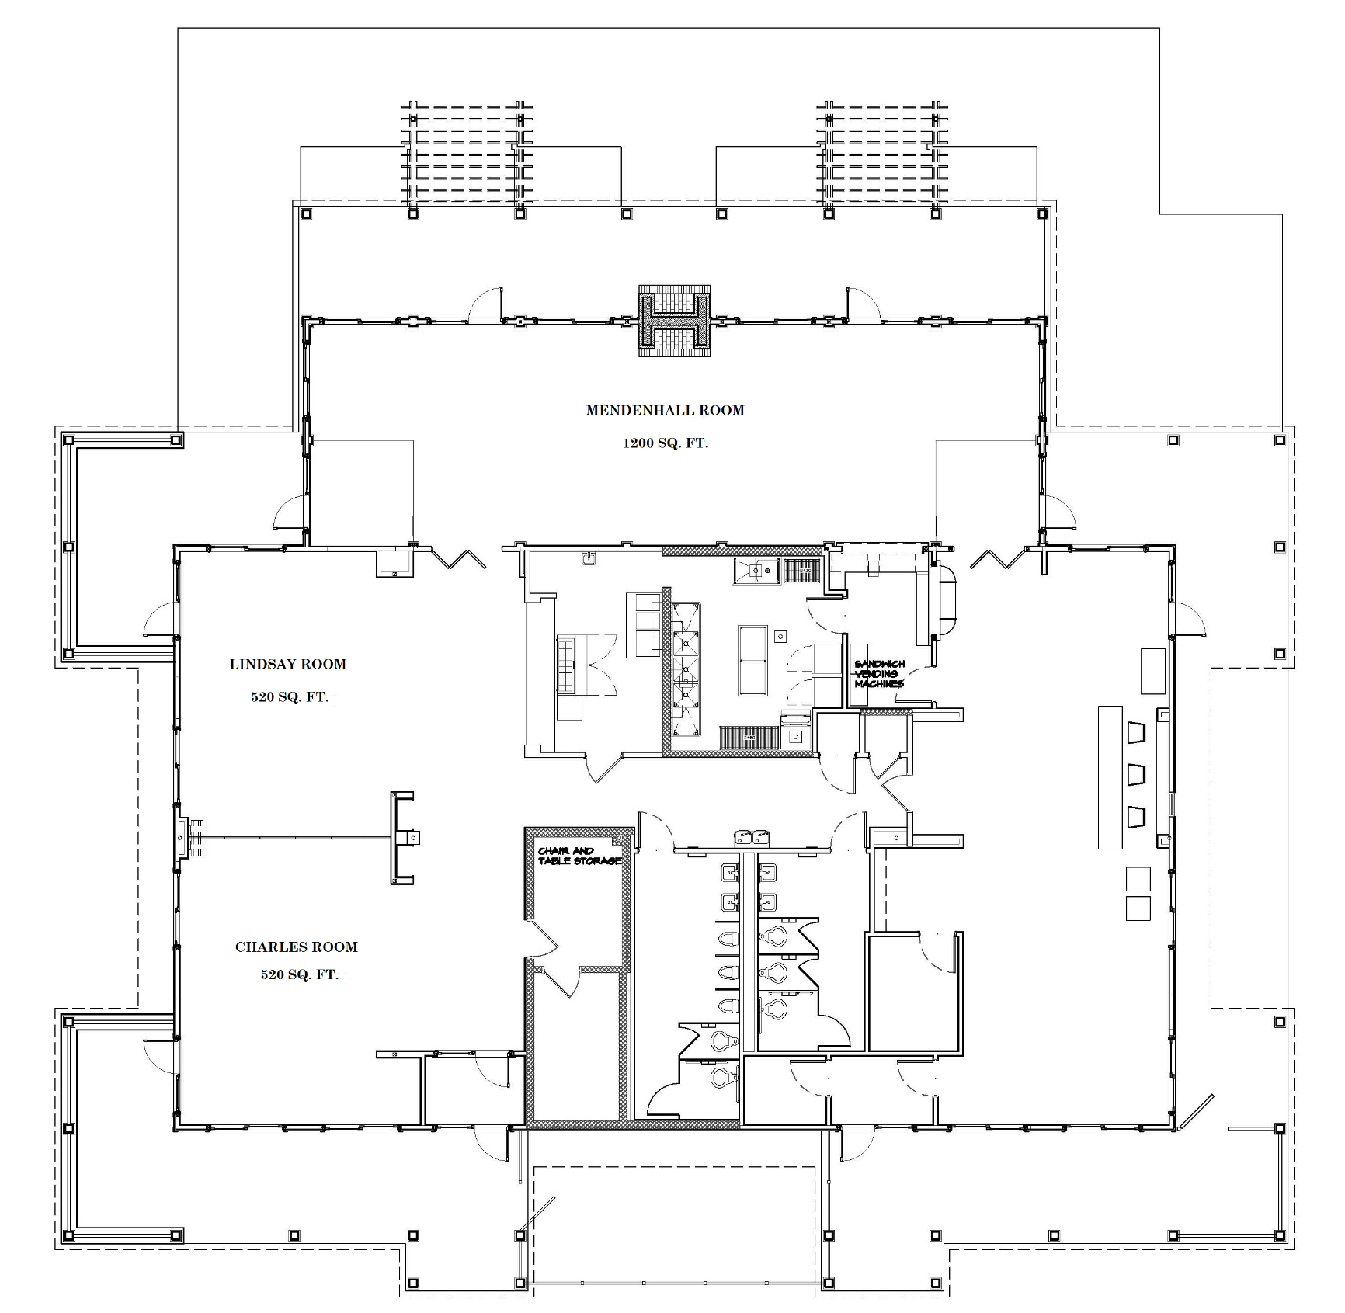

Effective July 1, 2022, as adopted by Town Council.