JAMESTOWN PARK CLUBHOUSE
Facility Use Guide
2018-2019

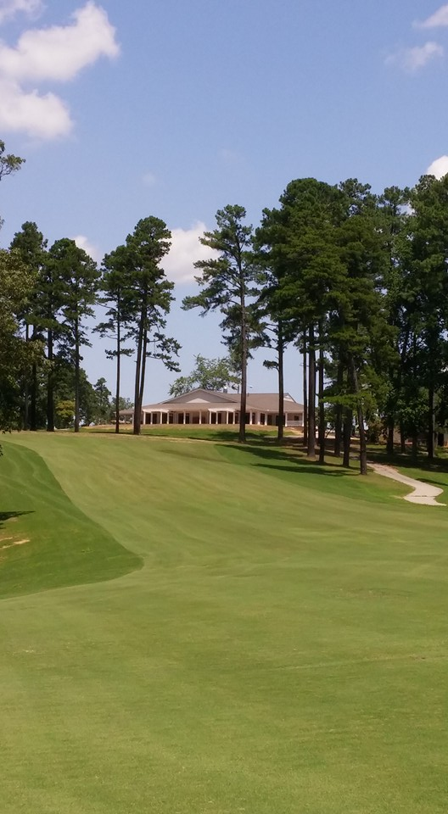

For information or to book an event date
contact Pro Shop at 336-454-4912
Website: http://www.jamestownparkgolf.com/

Thank you for choosing the Jamestown Park Clubhouse for your event. We look forward to working with you in making your event a success. Below is general information about the Clubhouse, which we encourage you to review as soon as possible. Jamestown Park Clubhouse is not available for rent on the evening before Thanksgiving, Thanksgiving Day, Christmas Eve and Christmas. When you sign the Rental Agreement you will be agreeing that you have read and understand all the information in this Facility Use Guide. Please contact the Town Hall staff if you have any questions.

Rental Agreement, Deposits & Final Payment: Your reservation will be confirmed when we receive your signed Rental Agreement, Rental Addendum, and Fees and Deposit. Any additional charges incurred will be deducted from your deposit before the deposit is refunded to you. A 10 day written notice of cancellation is required for your deposit to be returned. Make your checks payable to “Town of Jamestown”. Anyone leasing the Jamestown Park Clubhouse must be at least 25 years old. Only the rooms designated in the Agreement are to be used during your event.

Cost Estimate: The Rental Addendum is a cost estimate based on the information you gave us at the time of the rental.

Liability: You cannot have more people in the room(s) you have rented than our fire capacities allow. The Mendenhall room capacity is 79 and the Lindsay and Charles rooms will accommodate 72. When staging tables and chairs for your event, there must be space in front of all entry/exit doors equal to or greater than a six (6) foot radius per the Fire Marshall. There are NO EXCEPTIONS to this rule. No smoking or tobacco products are allowed in the building. Any damage to the clubhouse caused by you or your guests will be taken out of your Deposit. The Town of Jamestown (dba Jamestown Park) is not responsible for any personal property or equipment brought to or left at the Clubhouse.

The renting individual or group, their guests and invitees, understand and agree that the Town of Jamestown (dba Jamestown Park) will not be responsible for injury to persons using the premises under the terms of the application, nor for damage to or loss of property brought onto the premises, and that the Town of Jamestown (dba Jamestown Park) will be held harmless for any such injury, damage or loss resulting from use of its property, including any court cost and attorney fees.

Catering Services: You are welcome to use any caterer on the Jamestown Park Clubhouse list of approved caterers. If you find a caterer you would like to use that is not on the list, we will work to add them provided they meet Jamestown Park Clubhouse requirements. Due to health code restrictions and security requirements no one may enter the kitchen facilities except the Jamestown Park Clubhouse Event Host. If it is agreed the Jamestown Park Clubhouse staff will provide food services, then charges for the same plus applicable taxes and service charges will be included in a Rental Addendum as agreed upon no later than two (2) weeks prior to the event.

Food Provided by You: You may bring in your own food or have your guests bring covered dishes. You will need to bring everything related to your food service. Due to health code restrictions and security requirements no one may enter the kitchen facilities except the Event Host. You are responsible for clearing your tables of all your trash and placing it in the trashcans we provide, but the Event Host will pull the trash bags and get them to the dumpster. All or a portion of your Deposit will be retained, if necessary, to cover the expense of excessive cleanup or any damages.

Beverage Service: All alcohol consumed at Jamestown Park Clubhouse must be purchased from and served by the Jamestown Park Clubhouse staff Event Host. Jamestown Park Clubhouse offers a Cash Bar as described in the Fees and Charges Sections.

Private Businesses: Private businesses may not rent the facilities for private business endeavors. There is no exception to this requirement.

Selling Tickets: Tickets or money exchange is not permitted at the clubhouse, including reselling alcohol from a hosted bar. Businesses selling products and events where the general public has been invited and an admission is being charged are expressly prohibited.

Decorations: Any decorations brought on site must be flame retardant and any live greenery must be cut within 24 hours of the function. You cannot affix anything on the walls, floors or ceiling with nails, staples, carpet tape or any other substance that might damage Jamestown Park or the clubhouse. Glitter, confetti, sparklers, canned string, or like products are not permitted. Bubbles and birdseed are allowed outside only. All decorations brought in by you must be removed at the conclusion of the event unless special permission and arrangements have been made in advance. Only enclosed flames are permitted (votive candles, candles floating in glass container, hurricane lamps, etc.)

Event Hosts: Event Hosts are scheduled to work based on agreed upon event schedule and approved access to the building. We schedule staff as Event Hosts based on when you tell us you plan to arrive. If you arrive prior to the scheduled time, the staff person may not yet be on site to assist you. (See Fees and Charges Section)

ROOM RENTAL RATES AND CHARGES

Mendenhall Room is available for rent from 8:00am to 4:00pm daily for an hourly rate of $75. An Event Host is included in this rate to assist your needs.

The combined Mendenhall, Lindsay, and Charles Rooms may be rented in the evenings after golf hours for $400 an evening.

The evening rental hours are scheduled as follows:
May through September 7:30pm to 11:00pm
October 6:00pm to 11:00pm
November through February 5:00pm to 11:00pm
March through April 6:00pm to 11:00pm

The Patio is for the use of all Jamestown Park customers. If your event is scheduled during golf play hours, you may not have exclusive use of the patio.

Jamestown residents will receive a 20 % discount on the evening room rental rate. Jamestown Civic Clubs may reserve meeting space in the Mendenhall Room at no rental cost for business (regularly scheduled) meetings. However, the Civic Club will be responsible for paying the fee of $50 per hour for the Event Host.

For determining residency within Jamestown, a resident is considered someone that lives within the corporate limits of the Town of Jamestown.

The Room Rental Fee includes the furniture (tables and chairs) available inside the rental room(s). You are responsible for renting from a rental company additional items you may need for your event.

The Deposit is $150.00 per event and must be paid when the Lease is signed. (Jamestown Civic Groups are exempt from the deposit requirement). This money will be refunded by check within 10 business days if the rooms you rent are left in satisfactory condition or will be retained if excessive clean-up or repairs are required after your event or if additional hours are required by the Event Host. To assure that you are leaving the room(s) in satisfactory condition, ask your Event Host to inspect before you leave.

JAMESTOWN PARK CLUBHOUSE EVENT HOST
Jamestown Park Clubhouse requires at least one Event Host for each event. This staff member will come on duty whenever the first person related to your event needs access to the building (i.e. you to decorate, your caterer, band or DJ, florist, cake maker, etc.) This time is established when your Lease and Addendum are prepared. The Event Host will be in the building and available throughout your event, remain until all guests have left to remove garbage, and then secure the building. Our staff is familiar with the building and is here to meet your facility-related needs as they arise. Additional Event Hosts may be required as determined by Jamestown Park Clubhouse management to ensure a successful event. Typically groups of 50 to 100 require a second Event Host, 100 to 150 a third Event Host. There is a fee of $50.00 per hour per each additional Event Host.

AVAILABLE BAR SERVICES
Jamestown Park Clubhouse offers beer and wine and requires town staff to serve your guests from the concession area. A valid ID is required from all guests who approach the bar and request an alcoholic beverage. At the discretion of Town Staff, paid security officers may also be required for your event at the rate of $30 per officer per hour. Under no circumstances is brown bagging permitted.

Depending on furniture needed in the room (buffet, cake and/or gift tables, etc.) or activities that will be taking place in the room (DJ or band, dancing, performances, etc.) then you would need to allow floor space to accommodate them and you would not be able to seat the maximum number of people.

ROOM | DIMENSIONS | SQ. FOOTAGE | OCCUPANCY
Mendenhall | 19’ X 62’ | 1200.0 | 72 Tables & Chairs  169 Chairs only  237 Standing Room Only
Lindsey & Charles | 20’ x 26’ | 520.0 | 79 Tables & Chairs  169 Chairs only  237 Standing Room Only

Jamestown Park Clubhouse Floor Plan

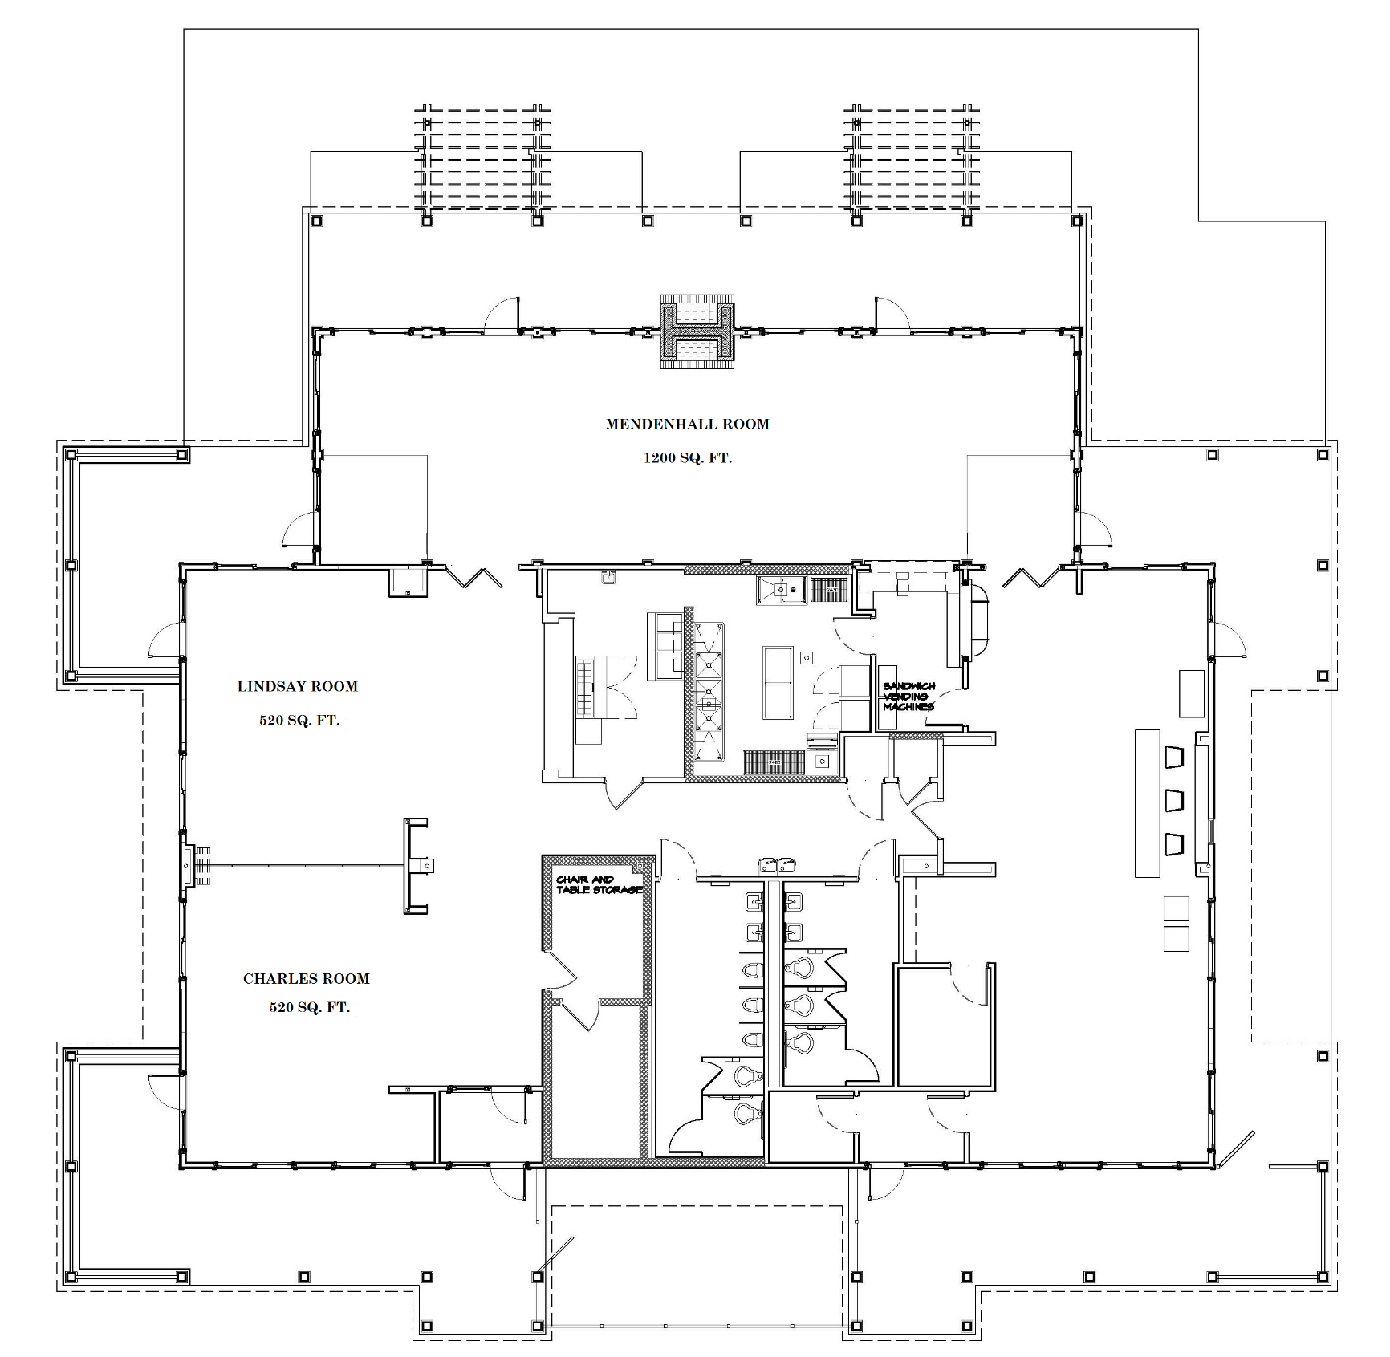

Effective November 15, 2016 as adopted by Town Council.

